**PIZZA SALES SQL QUERIES**

**A. KPI’s**

**1. Total Revenue:**

SELECT SUM(total_price) AS Total_Revenue FROM pizza_sales

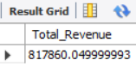

**2. Average Order Value:**

SELECT (SUM(total_price))/(COUNT(DISTINCT order_id)) AS Average_Order_Value FROM pizza_sales

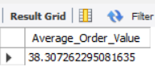

**3. Total Pizzas Sold**:

SELECT SUM(quantity) AS Total_Pizza_Sold FROM pizza_sales

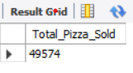

**4. Total Orders:**

SELECT COUNT(DISTINCT order_id ) AS Orders_Placed FROM pizza_sales

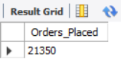

**5. Average Pizzas Per Order:**

SELECT SUM(quantity)/COUNT(DISTINCT order_id ) AS Average_pizza_per_order FROM pizza_sales

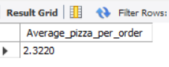

**B. Daily Trend for Total Orders**

SELECT DAYNAME(order_date) AS Order_day,COUNT(DISTINCT order_id) AS Total_Orders FROM pizza_sales GROUP BY DAYNAME(order_date) ORDER BY Total_Orders DESC

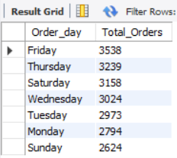

**C. Monthly Trend for Orders**

SELECT MONTHNAME(order_date) AS Order_day,COUNT(DISTINCT order_id) AS Total_Orders FROM pizza_sales GROUP BY MONTHNAME(order_date) ORDER BY Total_Orders DESC

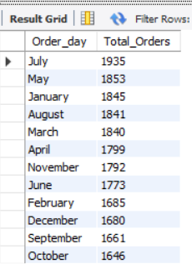

**D. % of Sales by Pizza Category**

SELECT pizza_category,SUM(total_price)*100/(SELECT SUM(total_price) FROM pizza_sales) AS Percentage_Category FROM pizza_sales

GROUP BY pizza_category ORDER BY Percentage_Category DESC

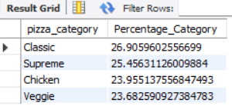

**E. % of Sales by Pizza Size**

SELECT pizza_size,SUM(total_price)*100/(SELECT SUM(total_price) FROM pizza_sales) AS Percentage_Category FROM pizza_sales

GROUP BY pizza_size ORDER BY Percentage_Category DESC

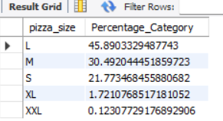

***NOTE***

If you want to get the result for specific month, you can use WHERE clause. Follow some of below examples.

SELECT pizza_size,SUM(total_price)*100/(SELECT SUM(total_price) FROM pizza_sales WHERE MONTH(order_date)=1) AS Percentage_Category FROM pizza_sales

WHERE MONTH(order_date)=1

GROUP BY pizza_size ORDER BY Percentage_Category DESC

**F. Total Pizzas Sold by Pizza Category**

SELECT pizza_category, SUM(quantity) as Total_Quantity_Sold

FROM pizza_sales GROUP BY pizza_category ORDER BY Total_Quantity_Sold DESC

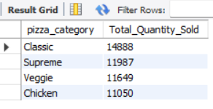

**G. Top 5 Pizzas by Revenue**

SELECT pizza_name,SUM(total_price) AS Total_Sales FROM pizza_sales

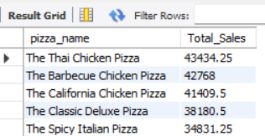GROUP BY pizza_name ORDER BY Total_Sales DESC LIMIT 5

**H. Bottom 5 Pizzas by Revenue**

SELECT pizza_name,SUM(total_price) AS Total_Sales FROM pizza_sales

GROUP BY pizza_name ORDER BY Total_Sales LIMIT 5

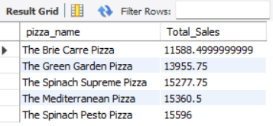

1. **Top 5 Pizzas by Quantity**

SELECT pizza_name,SUM(quantity) AS Total_Quantity FROM pizza_sales

GROUP BY pizza_name ORDER BY Total_Quantity DESC LIMIT 5

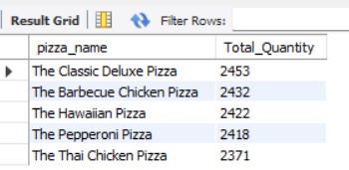

**J. Bottom 5 Pizzas by Quantity**

SELECT pizza_name,SUM(quantity) AS Total_Quantity FROM pizza_sales

GROUP BY pizza_name ORDER BY Total_Quantity LIMIT 5

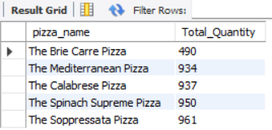

**K. Top 5 Pizzas by Total Orders**

SELECT pizza_name,COUNT(DISTINCT order_id) AS Total_Order FROM pizza_sales

GROUP BY pizza_name ORDER BY Total_Order DESC LIMIT 5

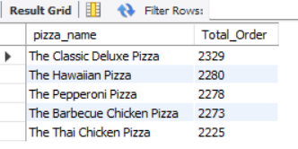

**L. Bottom 5 Pizzas by Total Orders**

SELECT pizza_name,COUNT(DISTINCT order_id) AS Total_Order FROM pizza_sales

GROUP BY pizza_name ORDER BY Total_Order LIMIT 5

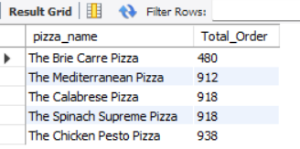

***NOTE***

If you want to apply the pizza_category or pizza_size filters to the above queries you can use WHERE clause. Follow some of below examples

SELECT pizza_name,COUNT(DISTINCT order_id) AS Total_Order FROM pizza_sales

WHERE pizza_category = 'Classic'

GROUP BY pizza_name ORDER BY Total_Order DESC LIMIT 5